Name:K Venkata Harshith

Roll No:121810313024

Bus Booking

Home Page

Html Code:

<!DOCTYPE html>

<html lang="en">

<head>

   <meta charset="UTF-8">

   <meta name="viewport" content="width=device-width, initial-scale=1.0">

   <title>Bus Booking</title>

</head>

<link rel="stylesheet" href="home_style.css">

<body>

<div class="Top_bar">

<img src="red_logo.PNG">

<a href="Signup.html"><p id="Top_item">SignUp</p></a>

<a href="login.html"><p id="Top_item">Login</p></a>

<p id="Top_item1">Bus Ticket</p>

<p id="Top_item1">rPool</p>

<p id="Top_item1">Bus Hire</p>

</div>

   <div id="bg">

<div  id="to-from">

</div>

   </div>

</body>

</html>

Css code(home_style.css):

*

{

   margin:0;

   padding:0;

}

.Top_bar

{

   height: 60px;

   width: 100%;

  background-color:#D54C58;

   float: right;

}

img {

   width: 100px;

   height: 60px;

 }

#Top_item

{

   position: relative;

   top: -37px;

   margin-right: 10px;

   float: right;

   font-size: 20px;

   color: white;

   margin-left: 20px;

}

#Top_item1

{

  position: relative;

  top: -37px;

  left: 100px;

   float: left;

   font-size: 20px;

   color: white;

   margin-left: 20px;

}

#bg

{

   position: relative;

   top: 60px;

   height: 500px;

   width: 100%;

   background-image: url('red_bus_main.png');

   background-size: 1300px 500px;

   background-repeat: no-repeat;

}

#tag1

{

   font-size: 24px;

   float:right;

   margin-top: 100px;

   margin-right: 30px;

   color: white;

   font-family: sans-serif;

   font-style: italic;

}

#tag2

{

   font-size: 24px;

   float: right;

   margin-top: 150px;

margin-right: -300px;

  opacity: 0.9;

   color: white;

   font-family: sans-serif;

   font-style: italic;

   }

Output:



Login Page

Html Code & Js Code:

<!DOCTYPE html>

<html lang="en">

<head>

   <meta charset="UTF-8">

   <meta name="viewport" content="width=device-width, initial-scale=1.0">

   <title>Login</title>

   <link rel="stylesheet" href="Login_style.css">

</head>

<body>

   <centre>

   <div class="Reg_form">

      <h1>Login </h1>

      <form id="reg" >

         <label>UserName:</label><br>

         <input type="text" id="name" placeholder="Enter Your Username" required><br><br>

         <label>Password:</label><br>

         <input type="password" id="name" placeholder="Enter Your Password" required><br><br>

          <input type="submit" onclick="myFunction()" id="sub" value = "Login"><br><br>

      </form>

      <p id="txt">Don't Have a account?</p>

      <a href="Signup.html"><p id="txt">Register</p></a>

   </div>

</centre>

<script>

   function myFunction() {

     alert("Sucessfully Logged in!!");

   }

   </script>

</body>

</html>

**Css code(Login_style.css):**

*

{

   margin:0;

   padding:0;

}

body{

   background-image: url('login_img.jpg');

   background-size: 1300px;

}

h1{

   color: seashell;

   text-align: center;

   font-family: sans-serif;

   font-style: italic;

}

.Reg_form{

   margin-top: 100px;

   width: 30%;

  margin-left: 35%;

   border: 2px solid white;

   border-radius: 5px;

   padding:25px;

   background-color: rgba(0,0,0,0.5);

   }

   label{

      color:whitesmoke;

      font-size:16px;

      font-family: sans-serif;

      font-style: italic;

   }

   ::placeholder{

      color:gray;

   }

   #name{

      width:250px;

      padding:5px;

      border:none;

      border-bottom: 2px solid gray;

      background: none;

      color: seashell;

   }

   #sub

{

   width:150px;

   padding:10px;

   color:white;

   background:red;

   border:none;

   border-radius: 5px;

   font-size:16px;

}

#txt

{

   color: white;

   font-family: sans-serif;

      font-style: italic;

}

**Output:**



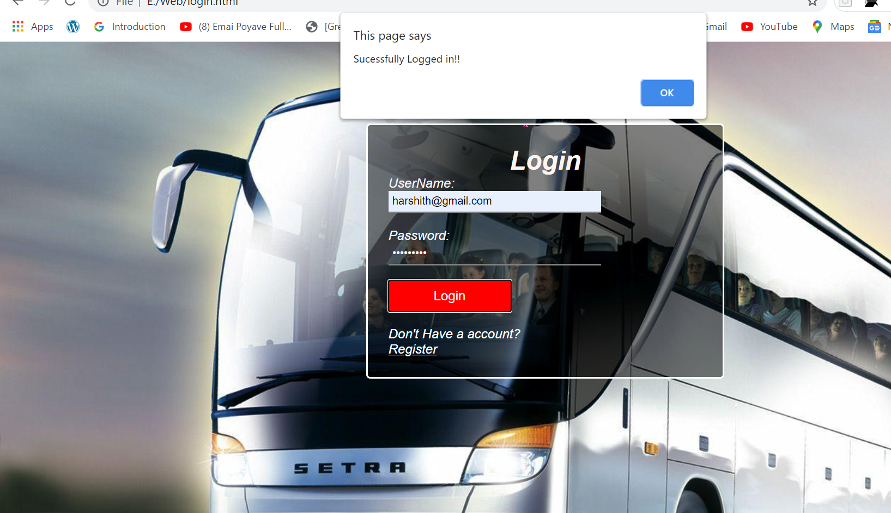

Registration Page

Html Code:

<!DOCTYPE html>

<html lang="en">

<head>

   <meta charset="UTF-8">

   <meta name="viewport" content="width=device-width, initial-scale=1.0">

   <title>Sigup page</title>

   <link rel="stylesheet" href="sign_up_style.css">

   <script src="validation.js"></script>

</head>

<body>

   <div class="Reg_form">

      <h1>User Registration Form</h1>

      <form id="reg" name="f1" >

         <label>First Name:</label><br>

         <input type="text" id="name" placeholder="Enter Your Firstname" required><br><br>

         <label>Last Name:</label><br>

         <input type="text" id="name" placeholder="Enter Your Lastname" required><br><br>

         <label>Email Id</label><br>

         <input type="email" id="name" placeholder="Enter Your Email Id" name="emailid" ><br><br>

         <label>Mobile Number:</label><br>

         <input type="number" id="name" placeholder="Enter Your Mobile Number" ><br><br>

         <label>Address:</label><br>

         <input type="text" id="name" placeholder="Enter Your Address" required><br><br>

         <label>Country:</label><br>

         <select  id="opt">

            <option class="opt1" >India</option>

            <option class="opt1">USA</option>

            <option class="opt1">UK</option>

            <option class="opt1">SriLanka</option>

          </select><br><br>

          <label>Password:</label><br>

          <input type="password" id="name" placeholder="Enter Your Password" name="pass"><br><br>

          <label>Confirm Password:</label><br>

          <input type="password" id="name" placeholder="Confirm Your Password" name="pass1"><br><br>

          <label>Gender:</label><br>

          <span id="male">Male</span> <input type="radio" id="ml" >

          <span id="male">Female</span> <input type="radio" id="ml" >

          <br><br>

          <input type="submit" id="sub" value = "Register.." onclick='myfun()'>

      </form>

   </div>

</body>

</html>

Css Code(sign_up_style.css):

*

{

   margin:0;

   padding:0;

}

body{

   background-image: url('sign_up_bg.jpg');

   background-size: 1300px;

}

h1{

   color: seashell;

   text-align: center;

   font-family: sans-serif;

   font-style: italic;

}

.Reg_form{

width: 50%;

margin: auto;

border: 2px solid white;

border-radius: 5px;

padding:25px;

background-color: rgba(0, 0, 0, 0.5);

}

label{

   color:whitesmoke;

   font-size:16px;

   font-family: sans-serif;

   font-style: italic;

}

::placeholder{

   color:rgb(46, 45, 45);

}

#name{

   width:250px;

   padding:5px;

   border:none;

   border-bottom: 2px solid gray;

   background: none;

   color: seashell;

}

#opt

{

padding: 3px;

border:none;

background:none;

border-bottom:2px solid gray;

width:250px;

}

.opt1

{

   background-color: white;

}

#male

{

   color:white;

   font-size:18px;

}

#sub

{

   width:150px;

   padding:10px;

   color:white;

   background:red;

   border:none;

   border-radius: 5px;

   font-size:16px;

}

Java script code(validation.js):

function myfun(){

   var fp=f1.pass.value;

   var sp=f1.pass1.value;

  var error_msg="";

  var inp=0;

  var em=0;

  var mail=f1.emailid.value;

   if(fp=="")

   {

      error_msg=error_msg+" enter some password"

   }

   else if(sp.length<6)

   {

      error_msg=error_msg+" Password must be greater than 6 chars"

   }

   else if(fp==sp)

   {

      inp=1;

   }

   else

   {

      error_msg=error_msg+" Password is not same"

   }

   if(mail=="")

         {

            error_msg=error_msg+" Enter some E-Mail"

         }

    else if(mail.indexOf('@')==-1 || mail.indexOf('.')==-1)

       {

         error_msg=error_msg+" It is a invalid email id"

       }

   else  if(mail.indexOf("@")==0 || mail.indexOf(".")==0 || mail.indexOf('@')>mail.indexOf('.') )

      {

         error_msg=error_msg+" It is a invalid email id"

      }

else if(mail.indexOf('@') +1== mail.indexOf('.'))

      {

         error_msg=error_msg+" It is a invalid email id"

      }

 else

   {

      em=1;

   }

   if(em==1 && inp==1 )

   {

      alert("Succesfully Submitted");

   }

   else{

      alert(error_msg)

   }

}

Output:

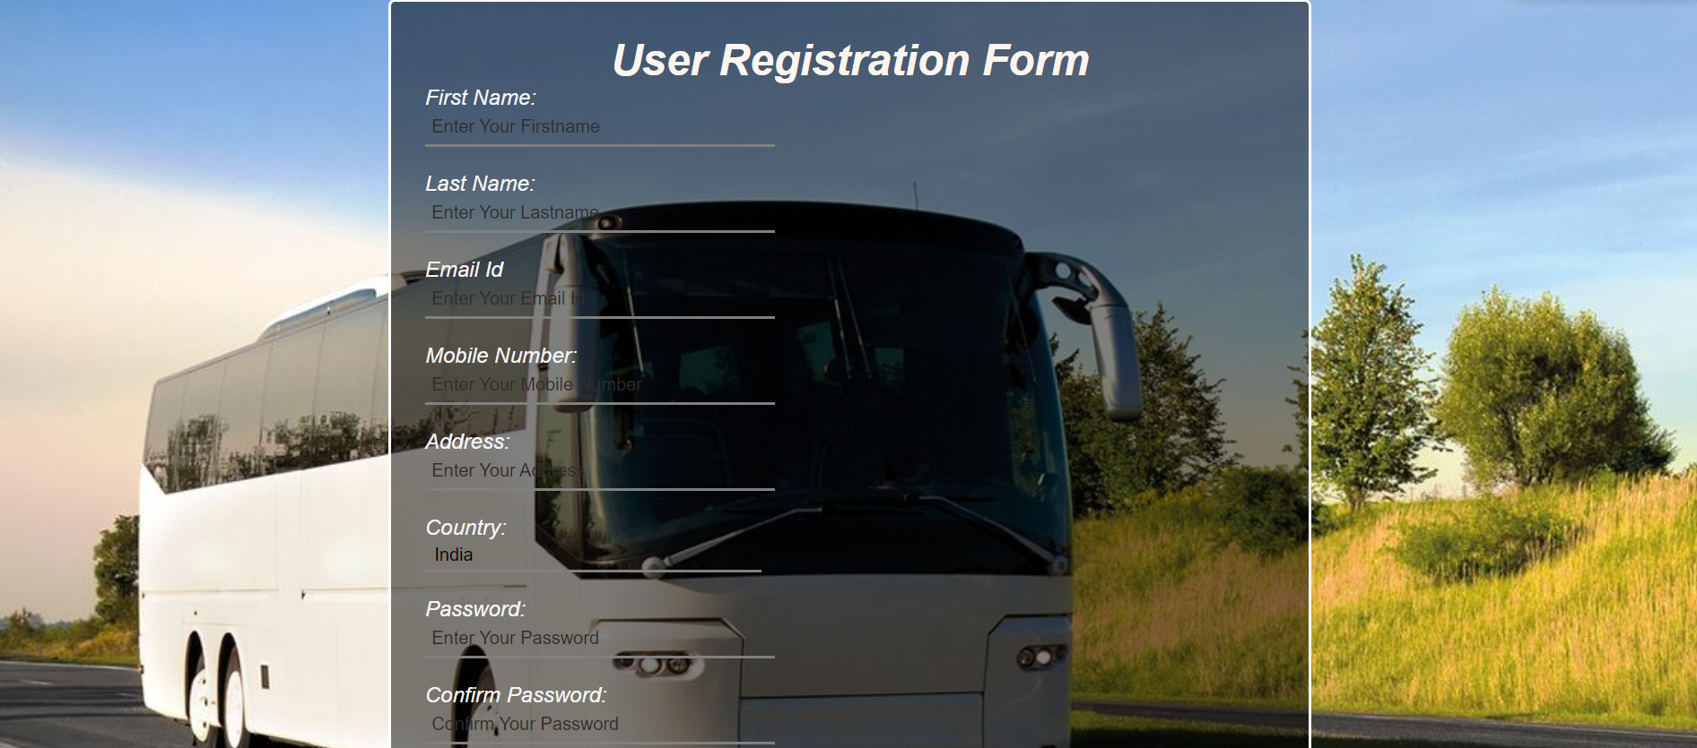



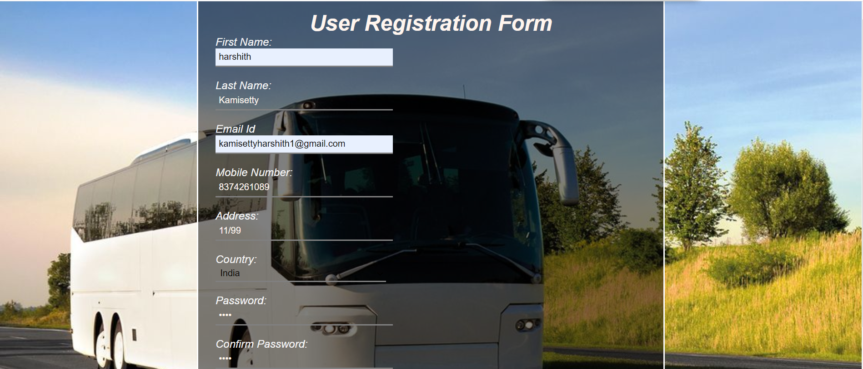 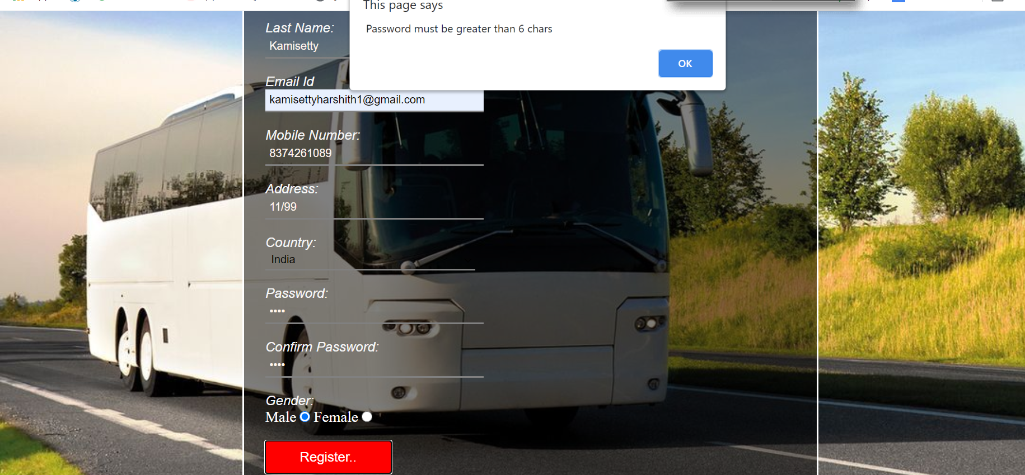

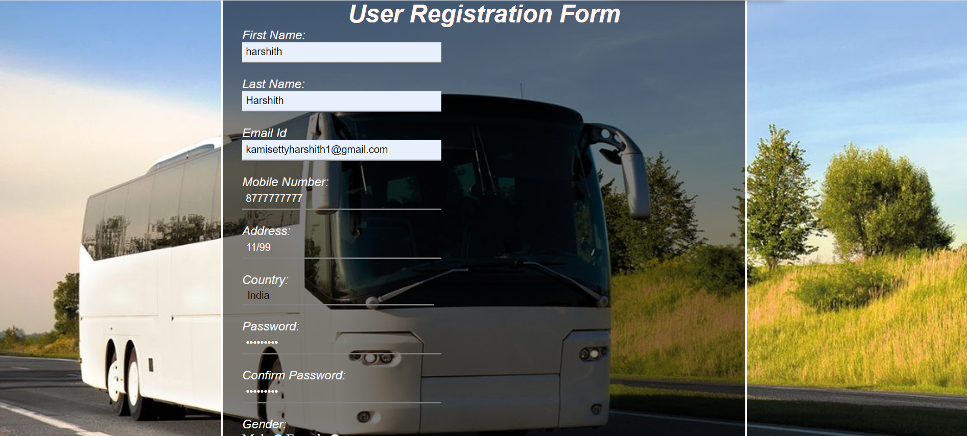 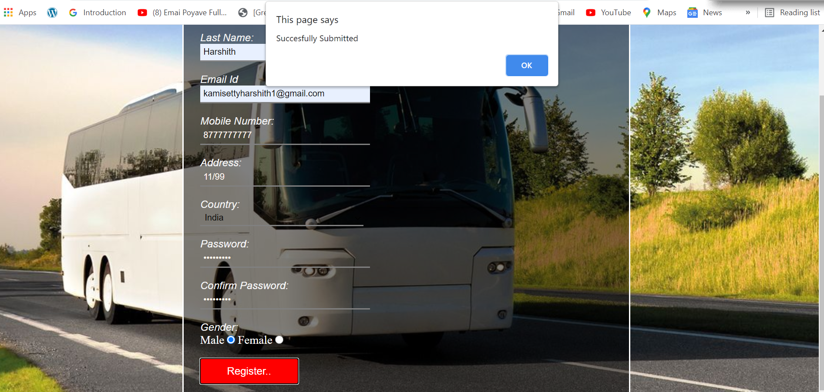

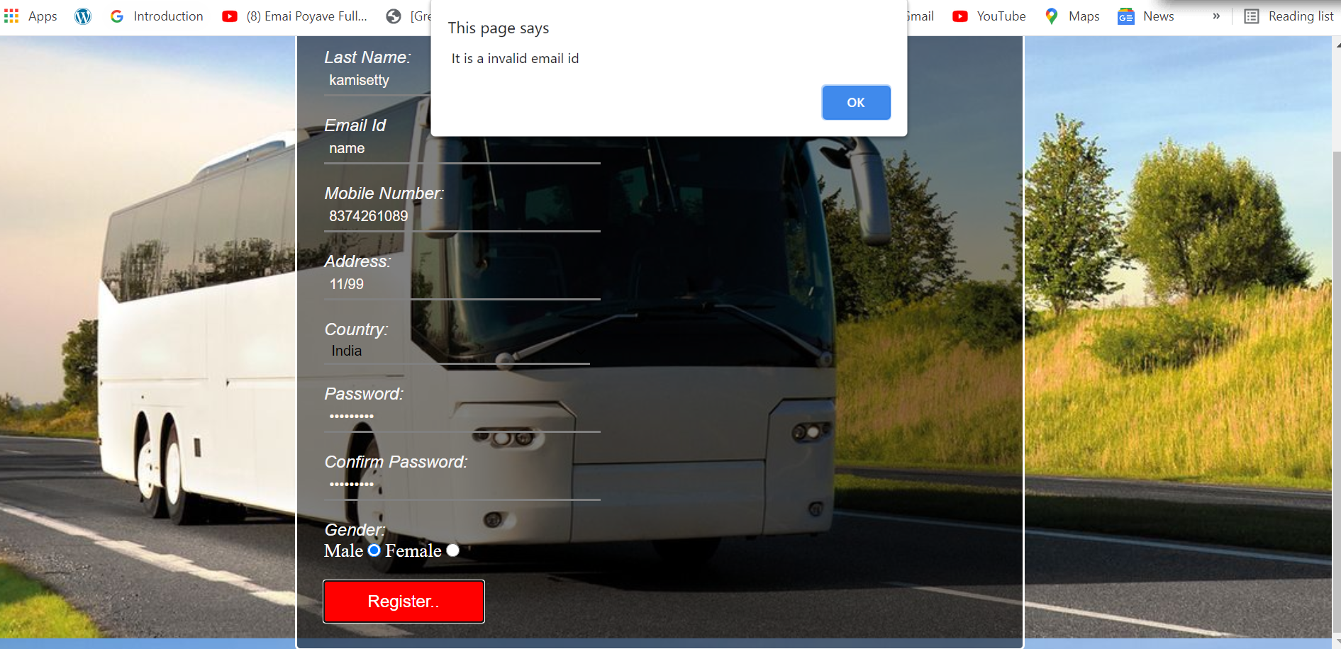

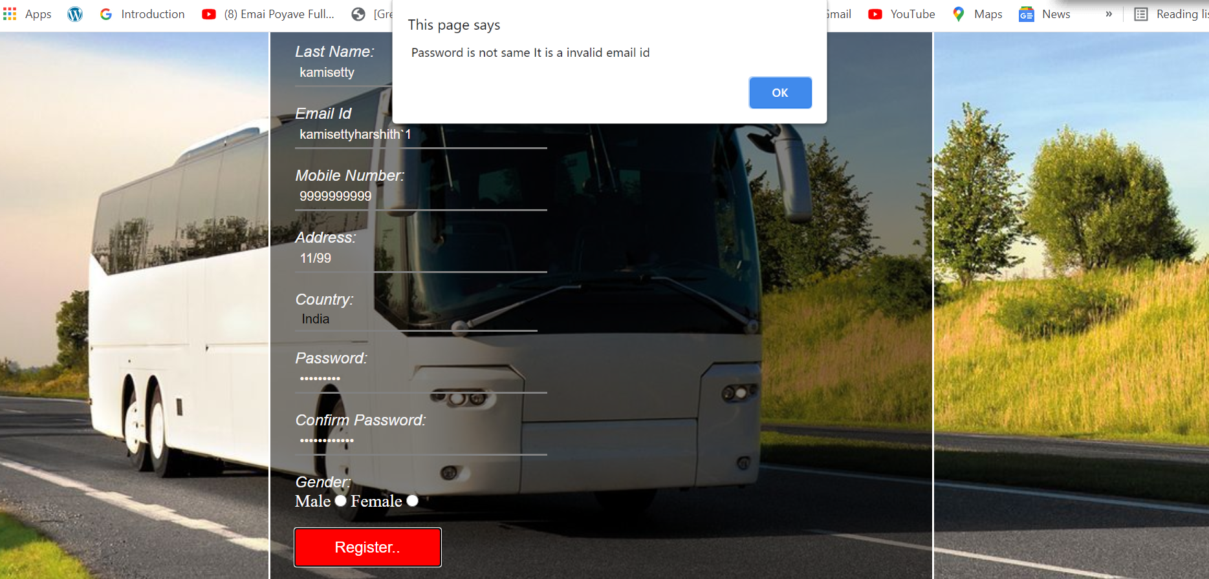

**2.Positioning(relative,absolute)**

**Html Code:**

<!DOCTYPE html>

<html>

   <head>

   <title>

   postioning.

   </title>

   </head>

   <body>

 <p>

    10th cgpa

    <span style="position: absolute;

    top: 17px;

    left: 80px;

    font-family: Times;

    font-style: italic; color:green;

    ">9.5</span>

 </p>

 <p>

   Inter percentage

   <span style="position: absolute;

   top: 49px;

   left: 120px;

   font-family: Times;

   font-style: italic; color:green;

   ">94%</span>

</p>

<p>

   Btech sem1

   <span style="position: absolute;

   top: 86px;

   left: 85px;

   font-family: Times;

   font-style: italic; color:green;

   ">8.81</span>

</p>

<p>

  btech sem2

   <span style="position: absolute;

   top: 122px;

   left: 80px;

   font-family: Times;

   font-style: italic; color:green;

   ">8.87</span>

</p>

<p>

Btech Sem3

   <span style="position: absolute;

   top: 158px;

   left: 85px;

   font-family: Times;

   font-style: italic; color:green;

   ">8.82</span>

</p>

<p>

 Btech Sem4

   <span style="position: absolute;

   top: 194px;

   left: 90px;

   font-family: Times;

   font-style: italic; color:green;

   ">8.9</span>

</p>

<p>

   Btech Sem 5

   <span style="position: absolute;

   top: 224px;

   left: 88px;

   font-family: Times;

   font-style: italic; color:green;

   ">9.1</span>

</p>

 <p>

   I Am son of<span style ="position: relative;top: 20px;

   font-family: Times;

   font-style: italic; color: red;">

 K Ravi Manohar </span>

 </p>

   </body>

</html>

**Output:**

